Enquiry module

# INTRODUCTION

The main aim of the module is to develop a strong and robust Enquiry System which will help the managerial team of WinPoint Learning Center to keep a track of their clients with ease and save a lot of time and efforts in managing the documents.

## Purpose

The whole and sole purpose of this module is to store and retrieve user’s enquiry related queries and preserve them for further processing.

## Scope

The scope of this module is to store user’s queries by providing an extensive form which would contain fields to be filled by the user same as that of the physical enquiry form.

Once the form is submitted by the user, the obtained data will be stored into a database. The stored data further will be used by the managerial team of WinPoint Learning Center to make smart and effective decisions for launching a new course batch.

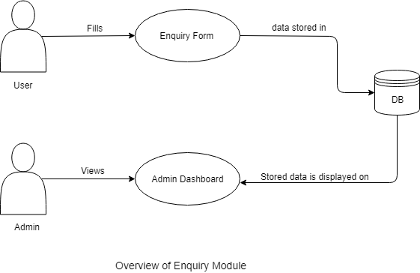

1. **User :-** Users mainly include the students, freshers, and working professionals. The product should be designed keeping all the users in mind.
2. **Admin :-** Admins mainly includes the managerial team of WinPoint Learning Center. The product should be easy to use for them.
3. **Database :-** A strong and robust database should be developed which will store all the user related queries and fetch and retrieve appropriate data to the admin.
4. **Enquiry Form :-** An attractive enquiry form will be designed which will include some mandatory fields such as name, email, contact, query, and the courses for which the user wants to enroll.

The basic template would somewhat look as follows :-

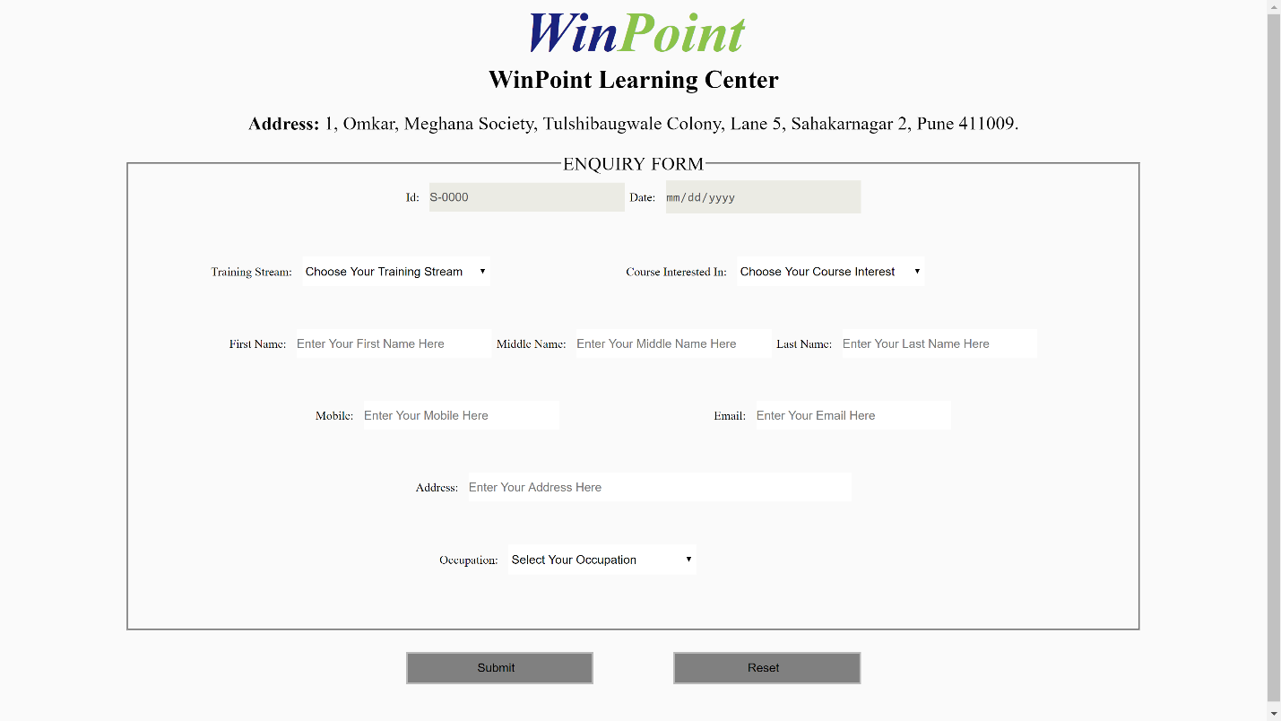

**(The above version of the form is tentative and needs to be revisited and redesigned)**

Once the student fills the form then all the data of the data fields will be stored in the database.

1. **Admin Dashboard :-** The admin dashboard would consist of the fields according to which we want to retrieve the data from the database. The results would be displayed in comparative forms by using extensive charts and models which will give the admin a clear insight of the types of enquires. There would be an option to send email to the required candidates when a batch is to be launched. The option would include sending individual emails to the enquired candidates as well as send the same email to multiple candidates.

**Detailed description of the module :-**

1. **Admin Module :-**

* Each admin will be able to see the enquiry details and the graphical analysis and results of the data of the enquiries.
* There will be an option to send mails to the candidates who have enquired for the batches.
* There will be an option to send whatsapp messages to the candidates who have enquired for the batches.
* The statistics for every course would be displayed which can be used for further analysis.
* Comparative study of the batches can be done.
* The data will be displayed as a list in the form of the table sorted as per the latest.
* Eligible not eligible feature, which will considered in enrolling the candidate for further admissions.
* Search feature for searching the enquiries.
* Inform the user when a new batch is started via mails and whatsapp messages continuously.
* Limit can be set in sending the emails and messages.

1. **Enquiry Form Module :-**

* Separate fields will be present for each of the users as per their category.
* Attractive form will be designed.
* The form fields will get stored in the database after submitting the form.

Here are some glimpses of the design of the form as well as the dashboard.

1. Client side form.

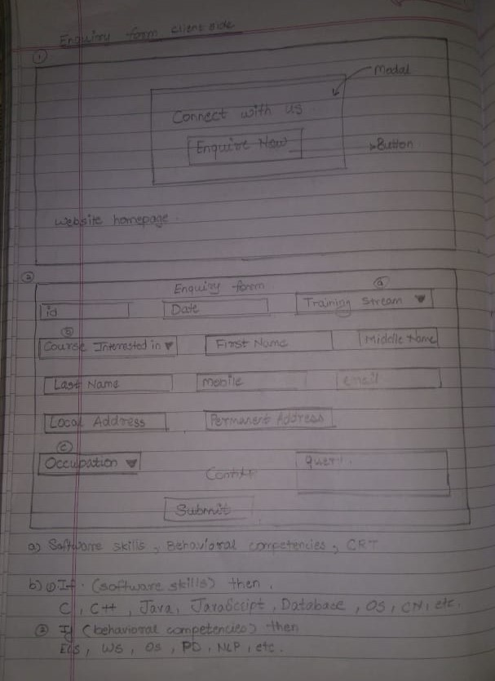

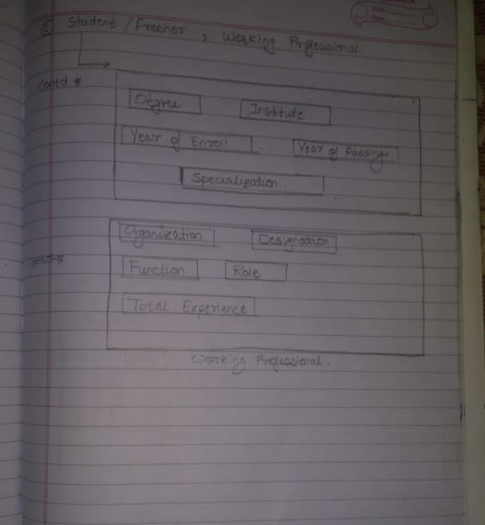

1. Admin dashboard.

